**Financial Analytics Report**

**AtliQ Technologies**

**Objective**: To understand the company’s performance over the FY 2019-23 and develop profitability and pricing strategies.

**Domain**: Finance| Supply chain

**Tools used**: SQL | MYSQL

1. **Introduction:**

This report aims to provide useful insights related to customer and market performance, top product in terms of quantity sold, revenue and gross margin on yearly basis for AtliQ hardware during FY 2019-23. The report also be used to draw data informed conclusions in setting financial and sales targets. This report can also be used for fact checking and decision-making during business reviews.

1. **Dataset Overview:**

The dataset provided by the data owners/stakeholders at Atliq Hardware is presented in the form of star schema in the next figure. The stakeholders have also requested useful insights in terms of top customers, products, market and regions over fiscal year.

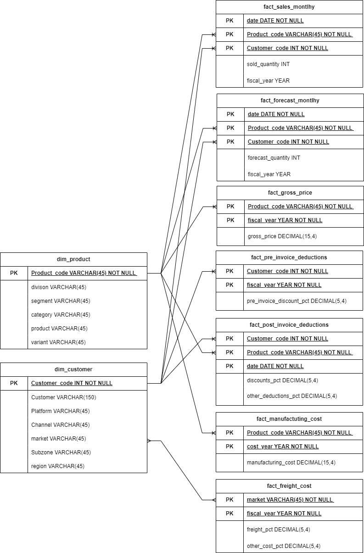

1. **Basic SQL Analysis**

**Step 1 – Importing the data to MYSQL**

* Importing SQL database to MYSQL and getting familiar with dataset tables
* Transform data
* Assigning appropriate data types
* Checking unique values and treating duplicate values
* Checking and treating null values and errors
* Trimming spaces

**Step 2-** Understanding the data

* Seeking relationship between data tables
* Identifying primary keys in the dimension tables and foreign keys in the fact tables
* Identify relevant data required to prepare report
* Identify any new column requirements

**Step 3-** Creating a fiscal_year generated column in fact_sales_monthly

**Step 4-** Creating user empathetic reports.

1. **Problem Statement and report generation**
2. Create a product wise sales report (aggregated in a monthly basis at the product level) for Croma India for fiscal year 2021 to track individual product sales and run product analytics on it. The report should have the following columns
   * Month
   * Product name and variant
   * Sold Quantity
   * Gross price per item
   * Gross price total

**SQL Query-**

**By basic query we have identify the customer code for croma India that is 90002002**

select

gp.date, gp.fiscal_year,gp.product_code, gp.product,

gp.variant, gp.customer_code, gp.sold_quantity,

gp.gross_price,gp.tot_gross_price

from tot_gross_price_view gp

where customer_code= 90002002 and fiscal_year=2021

**Execution**

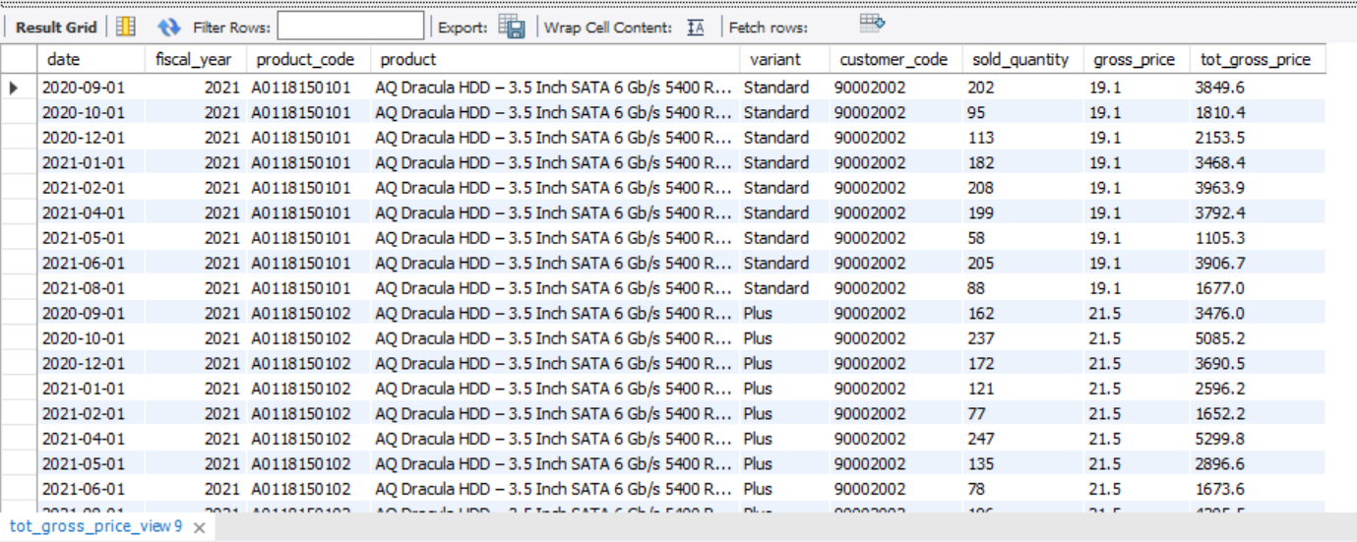

1. Create a stored procedure to determine the market badge based in the following logic. If total sold quantity > 5M that market is considered GOLD else it is SILVER
   * Input- Market and fiscal year
   * Output – Market badge

**SQL Query**

CREATE DEFINER=`root`@`localhost` PROCEDURE `market_badge`(

in_market varchar(45),

in_fiscal_year int

)

BEGIN

-- Set default market to be India if not provided

IF in_market = "" THEN

SET in_market = "India";

END IF;

(select

gp.market, sum(gp.sold_quantity) as qty_sold,

if(sum(gp.sold_quantity) > 5000000, "Gold", "silver") as market_badge

from tot_gross_price_view gp

where fiscal_year = in_fiscal_year and gp.market= in_market

group by gp.market);

END

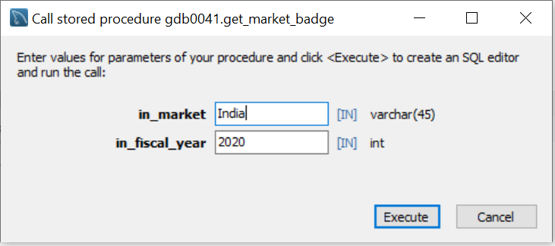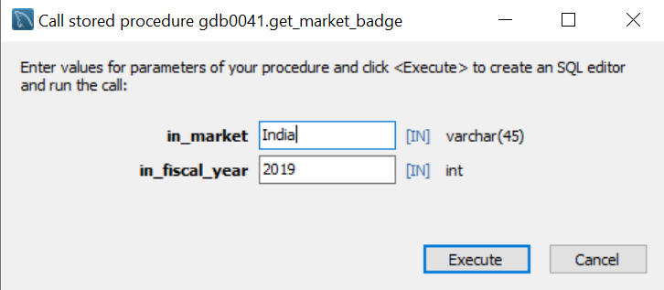  **Execution**

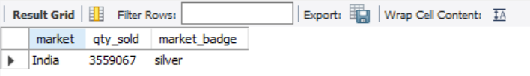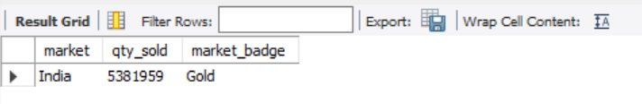

1. Create a report using stored procedure for top markets, products and customers by net sales for a given financial year to analyse the financial performance and take any appropriate actions to address any potential issues.

**SQL Query – Top Customer by net_sales**

CREATE DEFINER=`root`@`localhost` PROCEDURE `top_n_customer_by_net_sales`(

in_fiscal_year int,

in_top_n int

)

BEGIN

select

customer,

in_fiscal_year,

Round(sum(net_sales_amount)/1000000,2) as tot_net_sales_mln

from net_sales_view

where fiscal_year= in_fiscal_year

group by customer

order by tot_net_sales_mln desc

limit in_top_n;

END

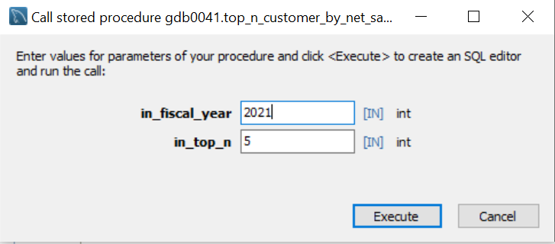**Execution – Top 5 Customer by net_sales in FY 2021**

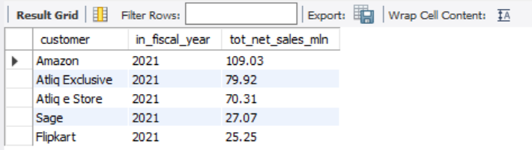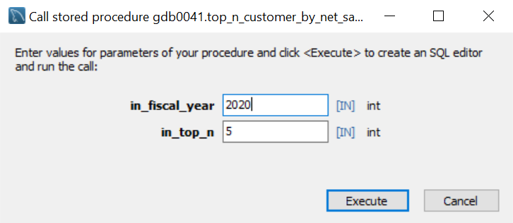

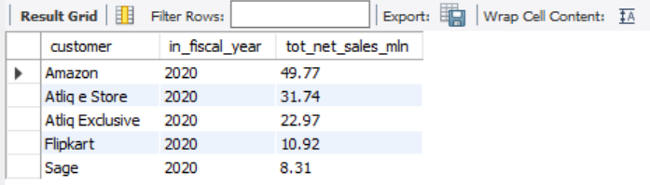

**SQL Query – Top Market by net_sales**

CREATE DEFINER=`root`@`localhost` PROCEDURE `top_n_market_by_net_sales`(

in_fiscal_year int,

in_top_n int

)

BEGIN

select

market,

in_fiscal_year,

Round(sum(net_sales_amount)/1000000,1) as tot_net_sales_mln

from net_sales_view ns

where fiscal_year= in_fiscal_year

group by market

order by tot_net_sales_mln desc

limit in_top_n;

END

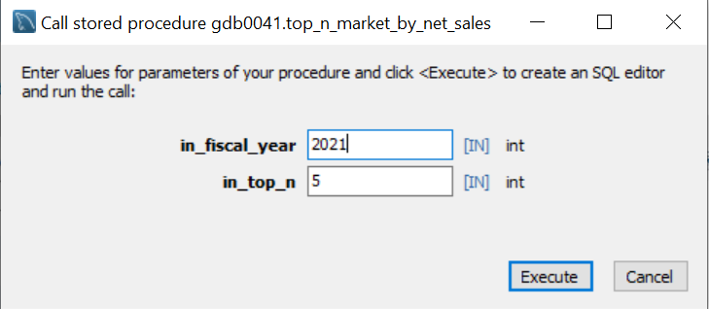**Execution – Top 5 market by net_sales in FY 2021**

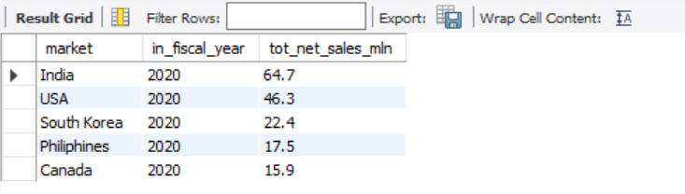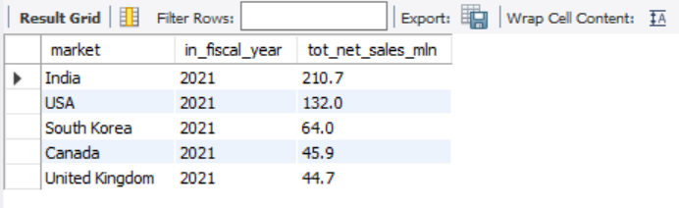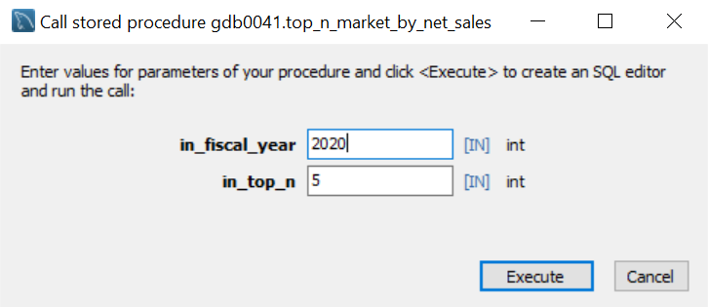

**SQL Query – Top Product for each division by quantity sold**

CREATE DEFINER=`root`@`localhost` PROCEDURE `top_n_product_by_divison_for_qty_sold`(

in_top_n int,

in_fiscal_year int

)

BEGIN

with cte1 as

(

select

p.division,

p.product,

sum(s.sold_quantity) as sold_qty,

dense_rank() over(partition by division order by sum(s.sold_quantity) desc) as dn_rnk

from fact_sales_monthly s

join dim_product p using (product_code)

where fiscal_year=in_fiscal_year

group by p.product,p.division

)

select

*

from cte1

where dn_rnk<=in_top_n;

END

**Execution – Top 2 Product for each division for quantity sold in FY 2021**

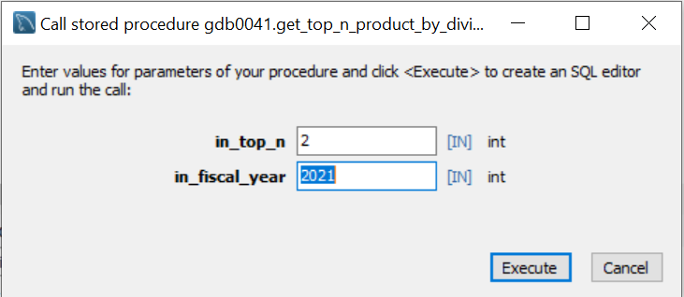

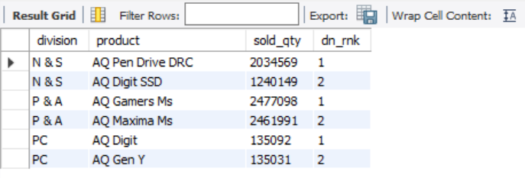

1. Create an aggregate forecast accuracy report for all customer for a given fiscal year to track the forecast accuracy and take appropriate action to reduce the excess inventory and opportunity cost. The report should have the following columns
   * Customer code, Name, market
   * Total sold Quantity
   * Total forecast Quantity
   * Net Error
   * Absolute Error
   * Forecast Accuracy %

**SQL Query – Forecast Accuracy report-** This would require making a temporary table fact_act_est by joining fact_sales_monthly and fact_forecast_monthly table.

DROP TEMPORARY TABLE IF EXISTS forecast_err_table;

CREATE TEMPORARY TABLE forecast_err_table AS

SELECT

customer_code,

SUM(sold_quantity) AS tot_sold_qty,

SUM(forecast_quantity) AS tot_forecast_qty,

SUM(forecast_quantity - sold_quantity) AS net_error,

SUM(forecast_quantity - sold_quantity) * 100 /sum(forecast_quantity) AS net_error_pct,

SUM(ABS(forecast_quantity - sold_quantity)) AS abs_error,

SUM(ABS(forecast_quantity - sold_quantity)) * 100 / Sum(forecast_quantity) AS abs_error_pct

FROM

fact_act_est

WHERE

fiscal_year = 2021

GROUP BY

customer_code;

select e.*, c.customer, c.market,

If(abs_error_pct>100,0,(100-abs_error_pct)) as forecast_accuracy

from forecast_err_table e

join dim_customer c using (customer_code)

order by forecast_accuracy desc;

**Execution**

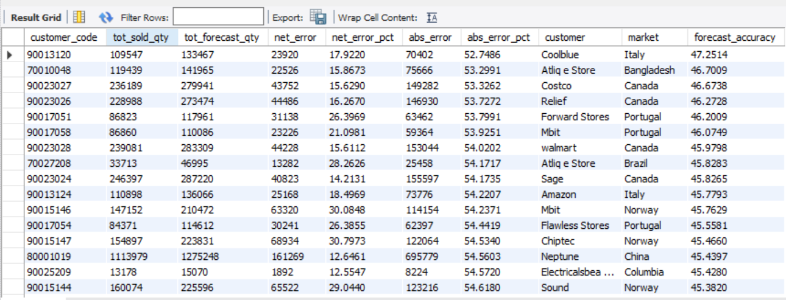

1. **Results and Conclusions**

**Note:** Refer to the excel file/ PDF reports for more information

- India has entered from silver market badge in 2019 to gold market badge in 2020 and maintained its badge consistently since then.

- Top and Bottom customer/market by net sales provides useful insights to the sales and marketing team to develop customer/market based strategies either to promote sales or might suspend operations in worst performing markets.

- Top and bottom products by quantity sold gives targeted product each division. Product based strategies to promote worst performing products could help grow net sales.

- Forecast accuracy report for all customer tracks the forecast accuracy and promote appropriate actions to reduce the excess inventory and opportunity cost and thus increasing revenue.